Shreveport
Computype, Inc.
Nexstep Automation
1995 County Road B2, Suite J
St. Paul, MN 55113-2726
3-Axis Label Applicator
Job Administrators
Users Manual


Table of Contents
Introduction
Start-up
Global
Jobs
Add data point
File Menu
Jobs Database
Table of Figures
Figure 1 JobAdmin icon
Figure 2 Open Job Database
Figure 3 Global Dialog
Figure 4 Jobs Dialog
Figure 5 Add label location
Figure 6 File Menu

Introduction
This document describes the usage of the JobAdmin program. The JobAdmin provides for maintaining the Jobs Database. The Jobs File Database is a Microsoft Access 7 database. The Jobs Database can be manipulated using Access. However, this program assures that the proper relation ships are maintained between the Job table and the Label Data Point table. See page 9 for the description of the Jobs Database.
It is assumed that the user of this program is familiar with Microsoft Windows 95 terminology.

Start-up
On the desk top or under the Start menu open the JobAdmin icon [] to start the JobAdmin program. The splash screen will be displayed as JobAdmin initializes. During initialization the open file common dialog is displayed asking for a Jobs Database []. Choose a Jobs Database and click open. The Jobs database supplied with JobAdmin and Labeler is named “LucentTechSP.mdb”. When JobAdmin is initialized the main screen will be displayed.

Figure 1 JobAdmin icon
The main menu has two sections accessible through a tab control and two menu items. These are "Jobs" see section page 5, "Global" see Section page 3. The menu items are "File" see section page 8 and the help menu.
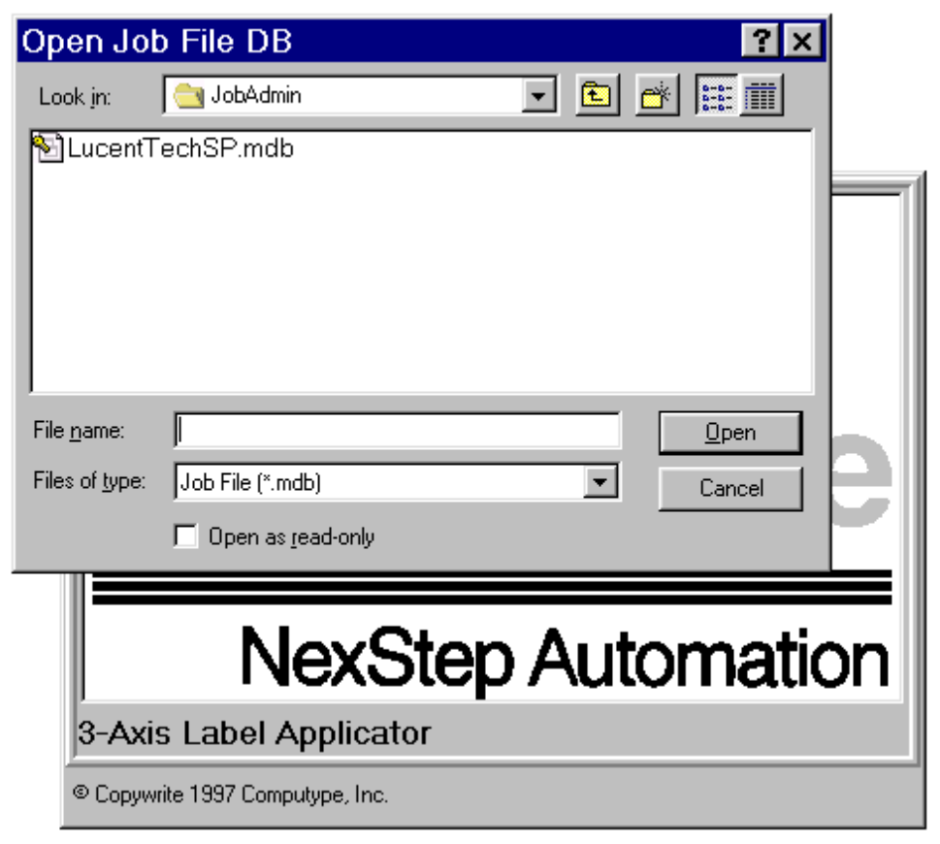
Figure 2 Open Job Database

Global
This tab dialog contains information that defines the data necessary to uniquely define the Labeler program for Lucent Technologies Shevport.
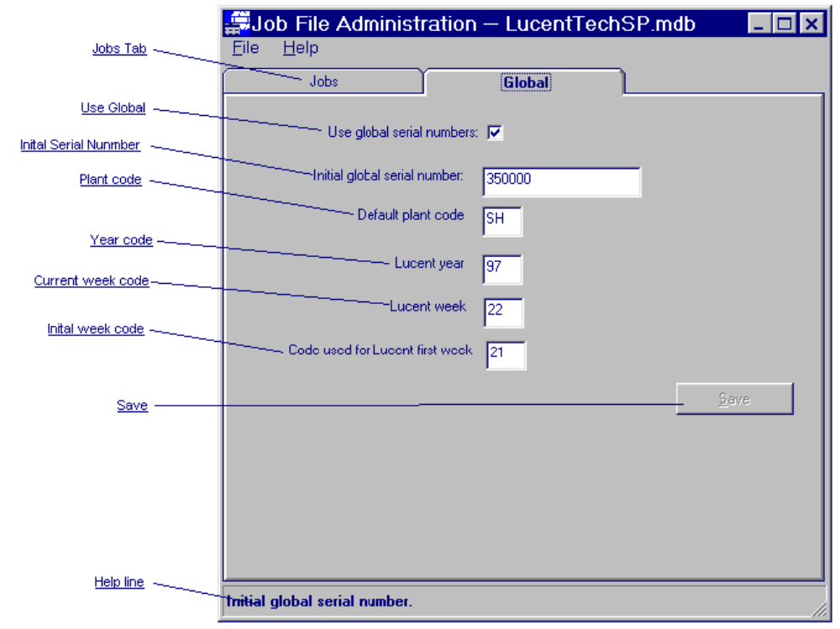
Figure 3 Global Dialog
Job tab
Click this tab to display the Job dialog.
Use Global
When this is checked the Labeler program uses the a global serial sequence, starting with the serial number described in , for all jobs. If it is unchecked the Labeler uses the serial number sequence described for each job. If it is unchecked each job must have a unique initial serial number and enough spread for all Concodes to have unique serial numbers across Comcodes.
Initial Serial Number
This field contains the serial number that the digital portion of the serial number is initialized to at the start of each week.
Plant code
This field contains the default two character plant code for all jobs.
Year Code
This field contains the current Lucent year code. This field is provided for use when Labeler's Jobs File Database is first installed or to re-sync the year code and should not be edited otherwise.
Current week code
This field contains the current Lucent week code. This field is provided for use when Labeler's Jobs Database is first installed or to re-sync the week code and should not be edited otherwise. The week code is incremented by 1 at the start of each week. There is no coordination between the data on the Labeler computer and this code other then when the code needs to be updated. This field is a two digit field that appears in the serial number as displayed. For example: If the week code needs to have 20 add to the week number then for the second week 22 needs to be entered.
Initial week code
This field contains the code for the first week of the Lucent year. At the start of the week, the week portion of the serial number is set to what is displayed. This field is a two digit field that appears in the serial number as displayed. For example: If the week number needs to have 20 add to the week number then this needs to have 21 entered.
Save
This button saves any changes to the Jobs Database.
help Line
This part of the form displays a short description of each field as the mouse is pass over it.

Jobs
This dialog provides for adding, editing, and deleting jobs in the Jobs File Database.
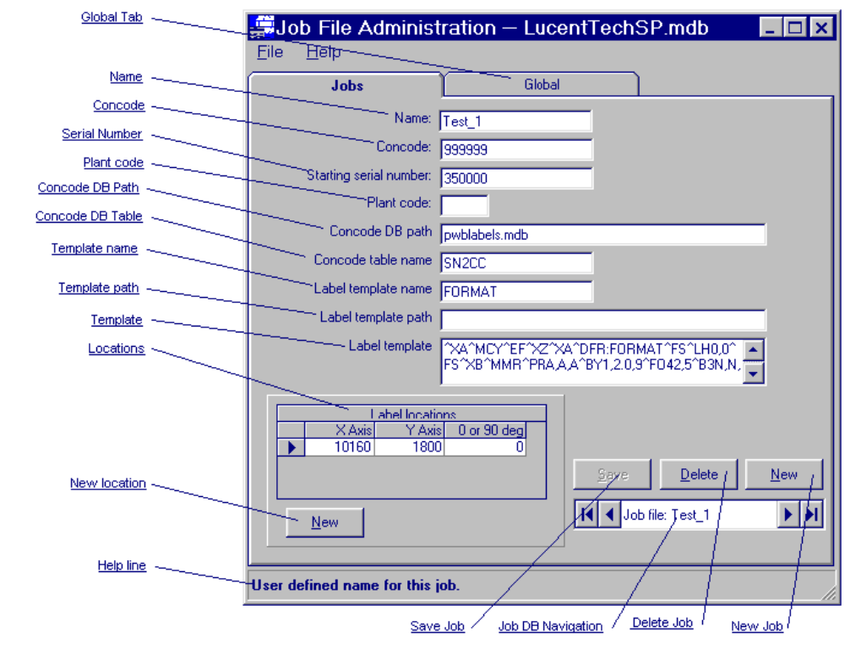
Figure 4 Jobs Dialog
Global Tab
Check this tab to display the global dialog.
Name
This field is for a user defined name for the this job.
Concode
This field is for Lucents Concede for the part being labeled by this job.
Starting serial number
This field is to edit the digit portion of the serial number. If use global is unchecked the Labeler uses the serial number sequence described here for this job. This job must have a unique initial serial number and enough spread from the pervious Concodes to have unique serial numbers.
Plant code
This is for the two character plant code specific to this job.
Concode DB path
This field is for the full path including filename and extension of pwblabels DB. This database must exists in the path specified.
Concode table
This field is for the name of table in pwblabels DB where the serial numbers, Concodes, and the data time stamp is stored for each label applied.
Template name
This field is for the name of the label template.
Template path
This field is for the full path including filename and extension of label template. This should not be filled in if the is filled in.
Template
This field id for the actual label template. This should not be filled in if the is filled in.
Locations
This grid contains the X,Y location of each label and it orientation with the conveyor rails. There is a row for each label and the labels are place on the panel in the order given. The locations are six (6) digits in .01 mm with an implied 2 place decimal. The location is referenced from the panel zero point. For example a location of 345.12mm is entered as 34512. The orientation is ether 0 or 90. Where 0 is parallel to the rails and 90 is perpendicular to the rails.
The locations and orientation can be edited in the cells. To add a new location use the New button []. To delete a location highlight the row by clicking on the row selector and use the Delete key.
New locations
Clicking this button displays the new location dialog box.
Save Job
Clicking this button saves the changes made to this job.
Delete Job
Clicking this button deletes this job.
New Job
Clicking this button add a new job to the database and displays a blank job dialog.
Job file navigator
Use this button to navigate through the Jobs Database.
Help line
This part of the form displays a short description of each field as the mouse is pass over it.

Add data point
This dialog provides a method to enter a new label location.
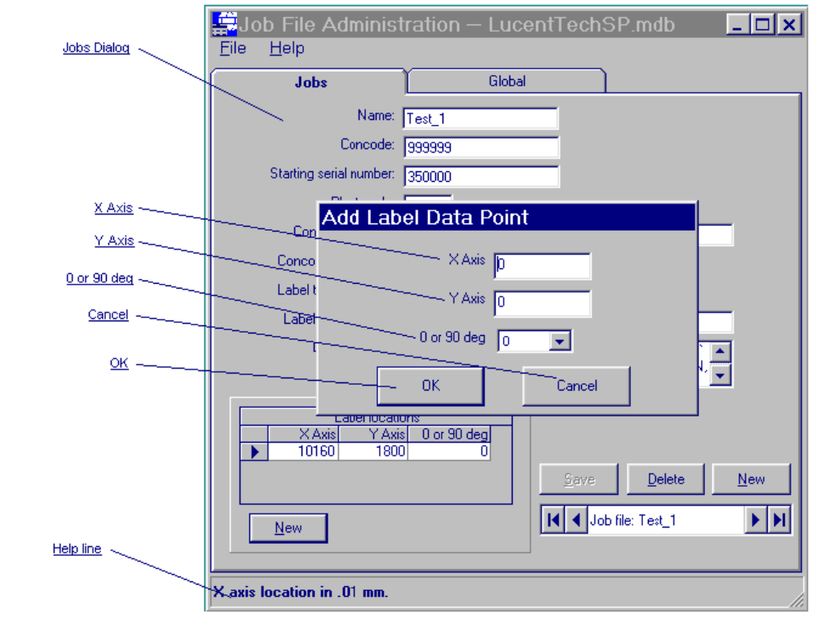
Figure 5 Add label location
The locations are six (6) digits in .01 mm with an implied 2 place decimal. The location is referenced from the panel zero point. For example a location of 345.12mm is entered as 34512. The orientation is ether 0 or 90. Where 0 is parallel to the rails and 90 is perpendicular to the rails.
Jobs Dialog
The dialog for the job the new location is being added to.
X Axis
In this field fill in the distance in mm parallel with the conveyor rails from the board zero reference.
Y Axis
In this field fill in the distance in mm perpendicular with the conveyor rails from the board zero reference.
0 or 90 deg
This will be 0 if the label is applied as picked up from the printer or 90 if it rotated before applied.
OK
Click this button to add this location to the current job.
Cancel
Click this button to disregard this dialog and return the jobs dialog.
Help line
This part of the form displays a short description of each field as the mouse is pass over it.

File Menu
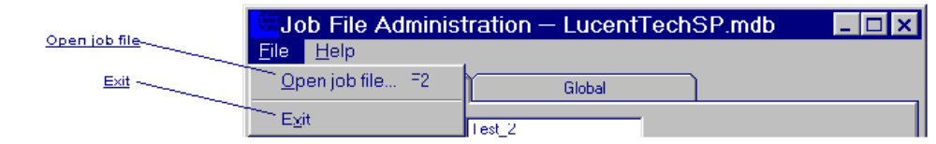
Figure 6 File Menu
Open job file
Displays the open file common dialog to open another Jobs Database.
Exit
Used to exit the program.

Jobs Database

Monday, March 31, 1997
Table: tblConfiguration Page: 1
Properties
ColIsGuid: s_GUID Date Created: 02/13/1997 2:11:33 PM
Def. Updatable: False Description: This table describes the
orientation of the panel to
applicator.

Last Updated: 03/14/1997 2:10:14 PM Order By On: False
Record Count: 1 Replicable: T
Columns
Name Type Size
s_Generation Number (Long) 4
s_GUID Replication ID 16
s_Lineage OLE Object -
ID Number (Long) 4
Name Text 50
YearCode Text 2
WeekCode Text 2
InitialWeekCode Text 50
DateWeekSet Date/Time 8
UseGlobalPN Yes/No 1
LastSerialNumber Text 6
InitialSerialNumber Text 6
DefalutePlantCode Text 2
Table Indexes
Name Number of Fields
ID 1
Fields: ID, Ascending
InitialWeekCode 1
Fields: InitialWeekCode, Ascending
PrimaryKey 1
Fields: ID, Ascending
s_Generation 1
Fields: s_Generation, Ascending
s_GUID 1
Fields: s_GUID, Ascending
WeekCode 1
Fields: WeekCode, Ascending
YearCode 1
Fields: YearCode, Ascending
Monday, March 31, 1997
Table: tblDataPoints Page: 2
Properties
ColIsGuid: s_GUID Date Created: 01/24/1997 9:43:25 AM
Def. Updatable: True Description: Contains the data points each
label

Last Updated: 03/27/1997 11:06:59 AM Order By On: True
Order By: tblDataPoints.DataPtName Record Count: 12
Replicable: T
Columns
Name Type Size
s_Generation Number (Long) 4
s_GUID Replication ID 16
s_Lineage OLE Object -
DataPtID Number (Long) 4
JobsID Number (Long) 4
XApplyPt Number (Long) 4
YApplyPt Number (Long) 4
ThataApply Text 3
LabelDefID Number (Long) 4
DataPtName Text 50
Table Indexes
Name Number of Fields
DataPtID 1
Fields: DataPtID, Ascending
JobsID 1
Fields: JobsID, Ascending
LabelDefID 1
Fields: LabelDefID, Ascending
PrimaryKey 1
Fields: DataPtID, Ascending
s_Generation 1
Fields: s_Generation, Ascending
s_GUID 1
Fields: s_GUID, Ascending
tblJobFiletblDataPoints 1
Fields: JobsID, Ascending
Monday, March 31, 1997
Table: tblJobFile Page: 3
Properties
ColIsGuid: s_GUID Date Created: 01/23/1997 4:34:40 PM
Def. Updatable: True Description: Contains the data for each job
(The old job file)

Last Updated: 03/31/1997 2:48:05 PM Order By On: True
Order By: tblJobFile.JobsName Record Count: 6
Replicable: T
Columns
Name Type Size
Gen_Tempate Number (Long) 4
s_Generation Number (Long) 4
s_GUID Replication ID 16
s_Lineage OLE Object -
JobsID Number (Long) 4
JobsName Text 50
JobsPartNumber Text 9
JobsDiscriptions Text 255
SerilNumberStart Text 6
LastSerialNumber Text 6
PlantCode Text 2
DBpath Text 255
TableName Text 50
TemplatePath Text 50
TemplateFields Number (Integer) 2
TemplateName Text 8
Tempate Memo -
Table Indexes
Name Number of Fields
JobsID 1
Fields: JobsID, Ascending
PlantCode 1
Fields: PlantCode, Ascending
PrimaryKey 1
Fields: JobsID, Ascending
s_Generation 1
Fields: s_Generation, Ascending
s_GUID 1
Fields: s_GUID, Ascending
Monday, March 31, 1997
Query: pqrDataPointInfo Page: 4
Properties
ColIsGuid: s_GUID Date Created: 01/24/1997 12:57:20 PM
Def. Updatable: True Description: Contains the data points each
label

Last Updated: 03/10/1997 9:15:16 AM ODBC Timeout: 60
Order By On: False Order By: tblDataPoints.DataPtName
Record Locks: No Locks Records Affected: 0
Replicable: T Returns Records: True
Type: Select
SQL
PARAMETERS JobID Long;
SELECT DISTINCTROW tblDataPoints.JobsID, tblDataPoints.XApplyPt, tblDataPoints.YApplyPt,
tblDataPoints.ThataApply, tblDataPoints.DataPtName
FROM tblDataPoints
WHERE (((tblDataPoints.JobsID)=[JobID]));

Query Parameters
Name Type
JobID Number (Long)
Monday, March 31, 1997
Query: pqrJobSerNumData Page: 5
Properties
ColIsGuid: s_GUID Date Created: 02/26/1997 12:22:50 PM
Def. Updatable: True Description: Contains the data for each job
(The old job file)

Last Updated: 03/10/1997 9:14:59 AM ODBC Timeout: 60
Order By On: False Order By: tblJobFile.JobsName
Record Locks: No Locks Records Affected: 0
Replicable: T Returns Records: True
Type: Select
SQL
PARAMETERS JobID Long;
SELECT DISTINCTROW tblJobFile.JobsID, tblJobFile.SerilNumberStart, tblJobFile.LastSerialNumber
FROM tblJobFile
WHERE (((tblJobFile.JobsID)=[JobID]));

Query Parameters
Name Type
JobID Number (Long)
Monday, March 31, 1997
Query: qurAllJobSerNumData Page: 6
Properties
ColIsGuid: s_GUID Date Created: 03/03/1997 10:47:46 AM
Def. Updatable: True Description:
Last Updated: 03/10/1997 9:15:23 AM ODBC Timeout: 60
Order By On: False Order By: tblJobFile.JobsName
Record Locks: No Locks Records Affected: 0
Replicable: T Returns Records: True
Type: Select
SQL
SELECT DISTINCTROW tblJobFile.JobsID, tblJobFile.SerilNumberStart, tblJobFile.LastSerialNumber
FROM tblJobFile;

Monday, March 31, 1997
Query: qurDataPointInfo Page: 7
Properties
ColIsGuid: s_GUID Date Created: 02/12/1997 1:31:21 PM
Def. Updatable: True Description: Contains the data points each
label

Last Updated: 03/10/1997 9:15:28 AM ODBC Timeout: 60
Order By On: False Order By: tblDataPoints.DataPtName
Record Locks: No Locks Records Affected: 0
Replicable: T Returns Records: True
Type: Select
SQL
SELECT DISTINCTROW tblDataPoints.JobsID, tblDataPoints.XApplyPt, tblDataPoints.YApplyPt,
tblDataPoints.ThataApply, tblDataPoints.DataPtName
FROM tblDataPoints;

Monday, March 31, 1997
Query: qurDateData Page: 8
Properties
ColIsGuid: s_GUID Date Created: 02/26/1997 11:00:02 AM
Def. Updatable: True Description: This table describes the
orientation of the panel to
applicator.

Last Updated: 03/26/1997 11:38:21 AM ODBC Timeout: 60
Order By On: False Record Locks: No Locks
Records Affected: 0 Replicable: T
Returns Records: True Type: Select
SQL
SELECT DISTINCTROW tblConfiguration.YearCode, tblConfiguration.InitialWeekCode,
tblConfiguration.WeekCode, tblConfiguration.LastSerialNumber, tblConfiguration.InitialSerialNumber,
tblConfiguration.UseGlobalPN
FROM tblConfiguration;

Monday, March 31, 1997
Query: qurJobFile Page: 9
Properties
ColIsGuid: s_GUID Date Created: 03/14/1997 2:27:58 PM
Def. Updatable: True Description: Contains the data for each job
(The old job file)

Last Updated: 03/14/1997 2:29:28 PM ODBC Timeout: 60
Order By On: False Order By: tblJobFile.JobsName
Record Locks: No Locks Records Affected: 0
Replicable: T Returns Records: True
Type: Select
SQL
SELECT DISTINCTROW tblJobFile.JobsID, tblJobFile.JobsName, tblJobFile.JobsPartNumber,
tblJobFile.JobsDiscriptions, tblJobFile.SerilNumberStart, tblJobFile.LastSerialNumber, tblJobFile.PlantCode,
tblJobFile.DBpath, tblJobFile.TableName, tblJobFile.TemplatePath, tblJobFile.TemplateFields,
tblJobFile.TemplateName, tblJobFile.Tempate
FROM tblJobFile
ORDER BY tblJobFile.JobsName;

Monday, March 31, 1997
Database: C:\Projects\LucentTechnologiesSP\LucentTechSP.mdb Page: 10
Properties
AccessVersion: 06.68 Build: 4
Collating Order: General Def. Updatable: True
DefaultPartner: {guid DesignMasterID: {guid
{00000000-0000-0000-0000-0000 {0D98F2C2-A9D5-11D0-8D76-00C
00000000}} 0A835F42B}}
LastNoOpCheck: 1535 LastUpdater: {guid
{C6398E86-8B36-11D0-8D76-00C
0A835F42B}}
MostRecentSyncPartner {guid Query Timeout: 60
{EAA5B0C2-9F7D-11D0-8D76-00
C0A835F42B}}
Records Affected: 0 ReorderTables: F
Replicable: T ReplicaID: {guid
{0D98F2C2-A9D5-11D0-8D76-00C
0A835F42B}}
RepVersion: 646 Show Values in 1
Show Values in 1 Show Values in 0
Show Values Limit: 1000 Transactions: True
Version: 3.0
User Permissions
admin
Group Permissions
Admins
Users
Monday, March 31, 1997
Relationships: All Page: 11
Relationships
tblJobFiletblDataPoints
tblJobFile tblDataPoints
JobsID 1 ∞ JobsID
Attributes: Enforced, Cascade Updates, Cascade Deletes
Permissions: One-To-Many

